THE NPO Program
FREE WEBSITE: Your organization is given a shop.com website [powered by Microsoft] with 2600 high quality exclusive products and access to 4000 + retailers [Walmart, Target, Dell, Home Depot, Advanced Auto etc.]
FREE FUNDRAISING VOLUNTEER TEAM: The marketing and management of the site is handled by a team of designated fundraising volunteers from shop.com, at no charge to your organization.
HOW IT WORKS:
- Supporters purchase products from the NPO’s shopping site.
- Your organization earns 20-40% in royalties on the purchase of exclusive products.
- Your organization also can earn points that can provide additional royalties.
- Supporters get cash-back for their purchases.
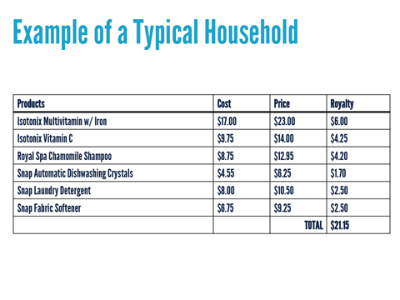
The products are high quality and priced fairly. Example below
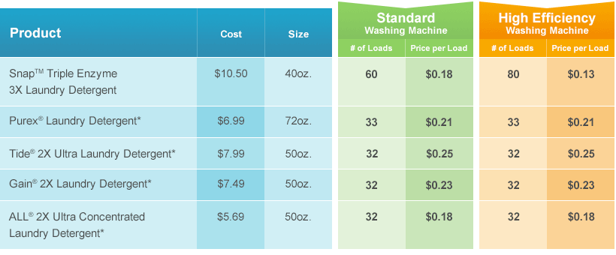
ITS WIN/WIN
Your organization earns $21.15 from this purchase [plus points toward additional revenue]
The supporter earns $2.08 in cashback from these purchases. [and saves money.]

